

*shell programming lab*

aSsignment -7

**SUBMITTED BY: SUBMITTED TO:**

**AYUSH KUMAR JHA Dr. Dhiviya Rose**

**SAP ID - 500086400**

**Enrollment no - R200220083**

**B.C.A -I.O.T.**

**EXPERIMENT – 9**

**TITLE:** Shell Scripts implementing Control Structure

**Activities:**

1. Write a shell script that computes the gross salary of a employee according to the following rules: i)If basic salary is < 1500 then HRA =10% of the basic and DA =90% of the basic. ii)If basic salary is >=1500 then HRA =Rs500 and DA=98% of the basic The basic salary is entered interactively through the key board.

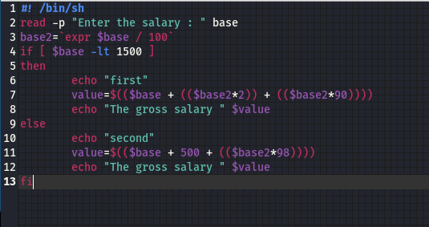

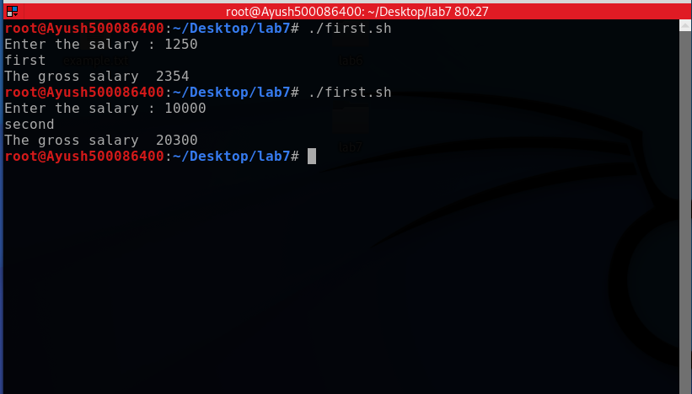

2. Write a shell script that uses the for and while loop construct respectively to print the message ”I Study in UPES” 5 times.

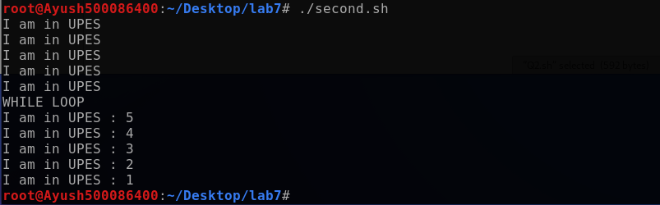

3. Find the maximum value from the three numbers entered by the user.

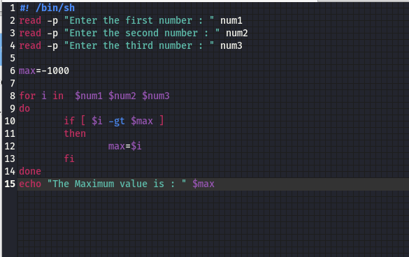

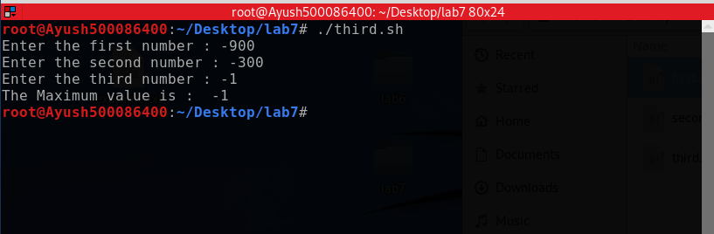

4. Accept two strings from the user and compare them using suitable string operators.

